***Software Design Specification Document***

GROUP MEMBERS

PRITIK SHRIVASTAVA (IIT2019192)

AKSHAY ANSHUL (IIB2019015)

GAURAV YADAV (IIB2019022)

ADITYA RAJ (IIB2019023)

**Table of Contents**

**1.** **INTRODUCTION 1**

1.1. Document Outline 2

1.2. Document Description 4

*1.2.1.* *Introduction 4*

*1.2.2.* *System Overview 5*

**2.** **DESIGN CONSIDERATIONS 5**

[2.1. Assumptions and Dependencies 5](https://docs.google.com/document/d/1ATy7nkTKqUFhipHzbI4CQB9f6jCqg-mQ/edit#heading=h.3o7alnk)

[2.2. General Constraints 5](https://docs.google.com/document/d/1ATy7nkTKqUFhipHzbI4CQB9f6jCqg-mQ/edit#heading=h.23ckvvd)

[2.3. Goals and Guidelines 6](https://docs.google.com/document/d/1ATy7nkTKqUFhipHzbI4CQB9f6jCqg-mQ/edit#heading=h.ihv636)

[2.4. Development Methods 6](https://docs.google.com/document/d/1ATy7nkTKqUFhipHzbI4CQB9f6jCqg-mQ/edit#heading=h.32hioqz)

[**3.** **ARCHITECTURAL STRATEGIES 6**](https://docs.google.com/document/d/1ATy7nkTKqUFhipHzbI4CQB9f6jCqg-mQ/edit#heading=h.1hmsyys)

[**4.** **SYSTEM ARCHITECTURE 7**](https://docs.google.com/document/d/1ATy7nkTKqUFhipHzbI4CQB9f6jCqg-mQ/edit#heading=h.41mghml)

[4.1. Subsystem Architecture 8](https://docs.google.com/document/d/1ATy7nkTKqUFhipHzbI4CQB9f6jCqg-mQ/edit#heading=h.2grqrue)

[**5.** **POLICIES AND TACTICS 8**](https://docs.google.com/document/d/1ATy7nkTKqUFhipHzbI4CQB9f6jCqg-mQ/edit#heading=h.vx1227)

[**6.** **DETAILED SYSTEM DESIGN 9**](https://docs.google.com/document/d/1ATy7nkTKqUFhipHzbI4CQB9f6jCqg-mQ/edit#heading=h.3fwokq0)

[6.1. Classification 9](https://docs.google.com/document/d/1ATy7nkTKqUFhipHzbI4CQB9f6jCqg-mQ/edit#heading=h.1v1yuxt)

[6.2. Definition 9](https://docs.google.com/document/d/1ATy7nkTKqUFhipHzbI4CQB9f6jCqg-mQ/edit#heading=h.4f1mdlm)

[6.3. Responsibilities 10](https://docs.google.com/document/d/1ATy7nkTKqUFhipHzbI4CQB9f6jCqg-mQ/edit#heading=h.2u6wntf)

[6.4. Constraints 10](https://docs.google.com/document/d/1ATy7nkTKqUFhipHzbI4CQB9f6jCqg-mQ/edit#heading=h.19c6y18)

[6.5. Composition 10](https://docs.google.com/document/d/1ATy7nkTKqUFhipHzbI4CQB9f6jCqg-mQ/edit#heading=h.3tbugp1)

[6.6. Uses/Interactions 10](https://docs.google.com/document/d/1ATy7nkTKqUFhipHzbI4CQB9f6jCqg-mQ/edit#heading=h.28h4qwu)

[6.7. Resources 10](https://docs.google.com/document/d/1ATy7nkTKqUFhipHzbI4CQB9f6jCqg-mQ/edit#heading=h.nmf14n)

[6.8. Processing 10](https://docs.google.com/document/d/1ATy7nkTKqUFhipHzbI4CQB9f6jCqg-mQ/edit#heading=h.37m2jsg)

[6.9. Interface/Exports 11](https://docs.google.com/document/d/1ATy7nkTKqUFhipHzbI4CQB9f6jCqg-mQ/edit#heading=h.1mrcu09)

[6.10. Detailed Subsystem Design 11](https://docs.google.com/document/d/1ATy7nkTKqUFhipHzbI4CQB9f6jCqg-mQ/edit#heading=h.46r0co2)

[**7.** **GLOSSARY 11**](https://docs.google.com/document/d/1ATy7nkTKqUFhipHzbI4CQB9f6jCqg-mQ/edit#heading=h.2lwamvv)

**8 BIBLIOGRAPHY 11**

# **1.Introduction**

## ***1.1. Document Outline***

Here it is an outline format to present the architecture and design of the entire system:

* Introduction
* System Overview
* Design Considerations
  + Assumptions and Dependencies
  + General Constraints
  + Goals and Guidelines
  + Development Methods
* Architectural Strategies
  + strategy-1 name or description
  + strategy-2 name or description
  + ...
* System Architecture
  + component-1 name or description
  + component-2 name or description
  + ...
* Policies and Tactics
  + policy/tactic-1 name or description
  + policy/tactic-2 name or description
  + ...
* Detailed System Design
  + module-1 name or description
  + module-2 name or description
  + ...
* Glossary
* Bibliography

## ***1.2. Document Description***

### **1.2.1. Introduction**

Provide an overview of the entire document:

* Describe the purpose of this document
* Describe the scope of this document
* Describe this document's intended audience
* Identify the system/product using any applicable names and/or version numbers.
* Provide references for any other pertinent documents such as:
  + Related and/or companion documents
  + Prerequisite documents
  + Documents which provide background and/or context for this document
  + Documents that result from this document (e.g. a test plan or a development plan)
* Define any important terms, acronyms, or abbreviations
* Summarize (or give an abstract for) the contents of this document.

**Purpose:**

*The main purpose is to make an Academic Management System(PLATO) for smooth running of all academic activities. The overall idea is to provide a software that offers a user friendly interface for management of academic affairs (Admissions, Assessments, Awards and Archives). It maintains track of the activities that have been performed by the logged-in user and stores information in a database so that it could be retrieved later. In simple words , it maintains the record of everything within the campus.Its other uses are :*

* *It leads to simple and smooth functioning of academic activities.*
* *Efficient Management And Organization of Timetables*
* *Reduction Of Human Labour, Papers and Workload*
* *Staff management*
* *Helps To Keep Track Of All Students*
* *Improved Communication*

**Scope:**

*Considering the scenario of IIITA, in this project we will develop an AMS application named as limbo that offers a user friendly interface for management of academic affairs (Admissions, Assessments, Awards and Archives). User authentication is done using a LDAP server. System administrator enables/disables the user account of LDAP server for access to AMS. System will track user activities and should maintain a log for each and every activity done by a logged-in user. Any operation on the database must be recorded in the form of log which is stored in the database (mysql or file) so that query can be performed in case of need. It will have various other functions too. It will be a software for the entire IIIT-Allahabad.Students along with the academic staff as well as administrative staff.*

**Intended Audience:**

*This document is intended for the director, administrator, other college staff and students. This document further contains a brief view of the structure of the software along with the functional and non-functional requirements . This document provides you an overview of the software giving information about the beginning of the proceedings .*

**References**

* [Software Design Document: What, Why and How? (Template Included) - Bit Blog](https://blog.bit.ai/software-design-document/)
* [How to Write Software Design Documents: With Examples](https://www.toptal.com/freelance/why-design-documents-matter)

**Acronyms**

*AMS - Academic Management System*

*LDAP - Lightweight Directory Access Protocol*

*REQ- Requirements*

### **1.2.2. System Overview**

Provide a general description of the software system including its functionality and matters related to the overall system and its design (perhaps including a discussion of the basic design approach or organization). Feel free to split this discussion up into subsections (and subsubsections, etc ...).

# **2.Design Considerations**

## ***2.1. Assumptions and Dependencies***

*This section lists the performance requirements expected/assumed from the web portal.*

* *The users shall be able to reach the website with proper internet connectivity.*
* *The navigation between pages shall take fewer than 5sec.*
* *The application shall be able to do a validation check on the information and notify when something went wrong*.
* *Loading speed should be less than 5 seconds.*

## ***2.2. General Constraints***

* *Should run on 500 MHz, 64 MB machine which is minimum required to run a web browser with proper internet connectivity.*
* *Students , Academic Staff,Administrative Staff, Hostel Warden, AAA members, Registra,Dean and Director,LAB staff as well should be able to login to the system through the first page of the web page.*
* *Students have to login in to the system to see their profile and update when required.*
* *The system is designed to be the cross platform supportable. Hence it is an extremely portable implementation.*
* *The system is implemented in a web environment.*
* *The Interface design is aimed at a flexible front-end communication to provide the user with clear information in navigating a user-friendly interface is planned.*
* *The software must have a simple, user-friendly interface so customers can save time and confusion.*

## ***2.3. Goals and Guidelines***

*The Academic Management System is meant to create a user friendly interface for students,faculty and administration to track all the academic activities of IIITA. It will be a replacement for the currently existing system in college to handle academic activities. It will provide an interface between the administration, academic staff and Students and here administration will work as the interface between the student and the academic staff.*

## ***2.4. Development Methods***

* *We will use a mysql database for storing students' information which is capable of handling a large concurrent database connection between student,academic staff and administration.*
* *Any operating system preferred: Windows 10, ubuntu.*

# **3. Architectural Strategies**

## **Hardware Interfaces**

Hardware interfaces like Laptop, Mobile, PC are those on which web browsers (i.e. Google chrome,

microsoft edge etc) can be installed to interact with the web portal.

The following hardware configurations are required for a PC :

Processor Intel dual core and above

32 MB of free hard-drive space.

128 MB of RAM

A good internet connection will be a bliss for smooth running of the software.

## **Software Interfaces**

We will use a mysql database for storing students' information.Django will provide a very good software interface between student and administration.

Here are the system requirement required for efficiently running the web portal

Any operating system preferred are: Windows 10, ubuntu,

A web browser:

Preferred google chrome

## **Communications Interfaces**

We will use http, protocol for fulfilling the request of the client. Our website will be hosted on a DNS server with a certain domain name and IP address assigned to it.The communication between the different parts of the system is important since they depend on each other. However, in what way the communication is achieved is not important for the system and is therefore handled by the underlying operating systems for web application.

# **4.System Architecture**

The various features of the system are described below :

## **System Feature 1**

4.1.1 Description and Priority

|  |  |  |
| --- | --- | --- |
| High Priority | Middle Priority | Low Priority |
| Batch-wise, program-wise, semester-wise course view | Faculty wise course allotment view | Profile view (Personnel details) |
| Details of students appearing for examinations | View of status of  -Exam schedule  -Penalty/disciplinary action | View course coordinators |
| Semester-wise and course-wise result view | Register for add ons | Class time-table view |
| -Elective details  -Project details | Room allotment | Exam schedule view |
| Batch-wise, program-wise, semester-wise course registration status view | Default/dues list display |  |
|  |  |  |

4.1.2 Stimulus/Response Sequences

There will be three types of user in this web portal. And following are the list of actions that can be performed by them.

## **4.1Subsystem Architecture**

1. **Director/Dean/Registrar/AAA Super User**

Log-in to the system.

They can view each student's profile and he can also remove any student from the list of registered students.

Add update and remove users.

They can view and analyse the result batch-wise, semester-wise, and program wise.

View of status of

* 1. Exam schedule
  2. Penalty/disciplinary action

He can view class time-table, course coordinator, exam schedule and he can make changes in this also.

He can edit and view the list of students appearing for the examinations.

**2. Administrative section**

Log in into the system.

View and update default and dues lists

**3. Student**

Log-in to the system set-up and update profile.

Students can do course registration.

View grades of respective courses.

Can register for addons.

**4.Academic Staff**

Log in to the system set-up

Academic staff can view and update schedule of courses.

Academic staff can view and update examination schedule.

Can award grades to the students for the allotted courses.

Manage Add-on portal.

**5.Warden**

Log into the system set-up.

Can allot rooms to students and view details of allotted rooms.

Can view list of unregistered students.

Can view/update list of dues and defaults of hostels.

**6. AAA**

Log in to the system.

View and update course list

View student profile

# **5.Policies and Tactics**

Developers can’t leave any cookie having user password and developer can’t access any personal information regarding College and Student. This should not consume more than 128 mb of RAM, it should respond to every client request within 2-3 second. We will use mysql database for storing user’s information,student details,course details, dues list and default list. It will not require any high qualification for running the website. Director/Dean/Registrar and AAA will be able to manage users,see each student profile, dues list and default list and he will be able to make changes and authenticate the committee. The UI will be made simple enough for the users to interact with.

* We will use MySql database
* This software could be run in any operating system like Linux, windows ,Mac etc.

# **6.Detailed System Design**

This section refers to the detailed system design about different classifications of our system created. A software module is the lowest level of design granularity in the system. Depending on the software development approach, there may be one or more modules per system.Also, this section provides the information needed for a system development team to actually build and integrate the hardware components, code and integrate the software components such as frontend to backend and backend to database.

## ***6.1.Classification***

## This is a kind of web application for smooth running of all academic management purposes.

***6.2. Definition***

The main purpose is to make an Academic Management System(AMS)for system administrators and other users. The overall idea is to provide a software that offers a user friendly interface for management of academic management. It maintains track of the activities that have been performed by the logged-in user and stores information in a database in the form of logs.

***6.3. Responsibilities***

This component plays an important role in building whole software. It takes care of the whole user's activities. It consists of a user interface which is the frontend part, backend part and also database part. In a more descriptive way, it manages user input and provides the output what they want. It covers the whole part of the AMS application.

## ***6.4. Constraints***

UI constraints can be:

1.System will not be able to be utilised for fee payment..

2.Attendence report may not be available.

;

## ***6.5. Composition***

It is composed of frontend, backend and database.

## ***6.6. Uses/Interactions***

The User Interface subsystem will provide each user with a predefined interface depending on their respective roles within the system. From here the users will have access to the system’s functions. Authorization services are required in order to login and display the interface. Provides communication between the users and the rest of the subsystems

## ***6.7. Interface/Exports***

Hardware interfaces like Laptop, Mobile, PC are those on which web browsers (i.e. Google chrome,

microsoft edge etc) can be installed to interact with the web portal.

The following hardware configurations are required for a PC :

Processor Intel dual core and above

32 MB of free hard-drive space.

128 MB of RAM

A good internet connection will be a bliss for smooth running of the software.

We will use a mysql database for storing students' information. Django will provide a very good software interface between student and administration.

Here are the system requirement required for efficiently running the web portal

Any operating system preferred are: Windows 10, ubuntu,

A web browser:

Preferred google chrome

## ***6.8. Detailed Subsystem Design***

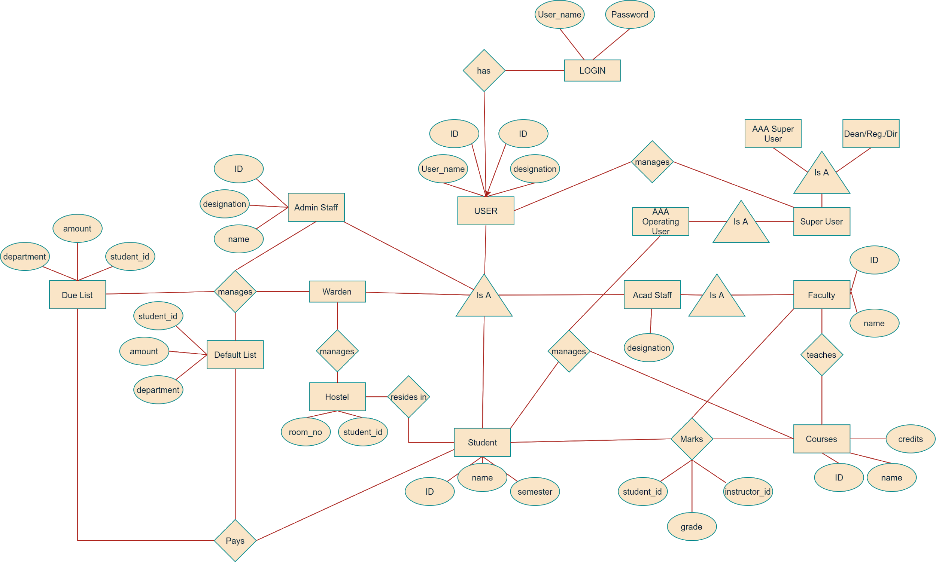

# **7. Glossary**

* *AMS - Academic Management System*
* *LDAP - Lightweight Directory Access Protocol*
* *REQ- Requirements*

# **8. Bibliography**

* [Software Design Document: What, Why and How? (Template Included) - Bit Blog](https://blog.bit.ai/software-design-document/)
* [How to Write Software Design Documents: With Examples](https://www.toptal.com/freelance/why-design-documents-matter)